Patel's Analog and Digital Measurement Co. Pvt. Ltd,
A/6 Functional Electronic Estate, Bhosari Indl. Area, Pune- 411026.
Tele: (020) 27120290/ 27120324, Fax: (020) 27122043
E-mail: padmco@vsnl.net , Arleen@dataone.in
_________________________________________________________________________________________________
Inquiry Form- Rotor Winding Machine
Please provide the requested information:
If engineering drawings are available, please send these with your enquiry.
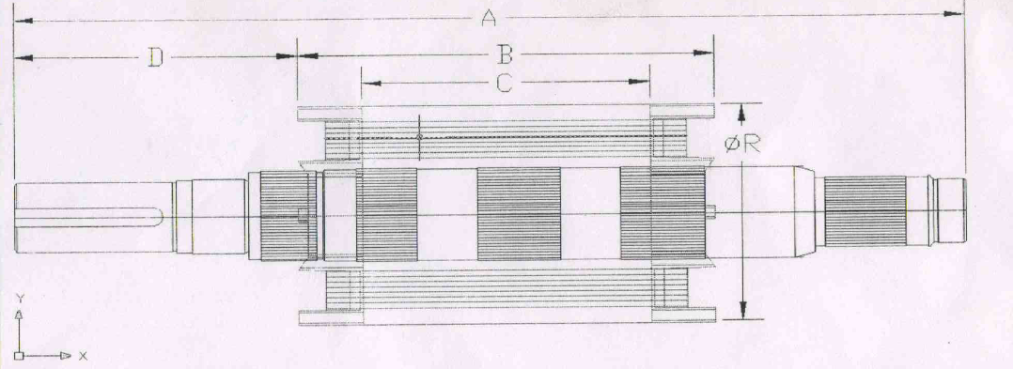

Rotor Winding Machine Enquiry Form
Weight of job before winding
(kg)
Weight of job after winding
(kg)
Type of Wire cross section/SWG
(ex: strip, round etc.)
Dimensions of cross section
(SWG/mm)
Weight of Wire in one job
(kg)
Number of turns
ABOUT WIRE
Wire Stock
(eg: Spool)
Weight of wire spool
(kg)
Spool Dimensions | OD  (mm) | ID  (mm) | Length  (mm)
Wire Type
(eg: Copper)
Rotor Dimensions
Overall Shaft Length
(A)-mm
Core Length Including Frontal Length
(B)-mm

Core Length
(C)-mm
Core Position
(D)-mm
Main Rotor OD
(ØR)-mm

Please fill your following information
Company name :
Company website, :
Company E-mail ID :
Company Contact No.

